**What Is a Capacitor?**

**A capacitor is a two-terminal electrical device that can store energy in the form of an electric charge. It consists of two electrical conductors that are separated by a distance.  The space between the conductors may be filled by vacuum or with an insulating material known as a dielectric. The ability of the capacitor to store charges is known as capacitance.**

**Capacitors store energy by holding apart pairs of opposite charges. The simplest design for a capacitor is a parallel plate, which consists of two metal plates with a gap between them. But, different types of capacitors are manufactured in many forms, styles, lengths, girths, and materials.**

## How Does a Capacitor Work?

**For demonstration, let us consider the most basic structure of a capacitor – the parallel plate capacitor. It consists of two parallel plates separated by a dielectric. When we connect a DC voltage source across the capacitor, one plate is connected to the positive end (plate I) and the other to the negative end (plate II). When the potential of the battery is applied across the capacitor, plate I become positive with respect to plate II. The current tries to flow through the capacitor at the steady-state condition from its positive plate to its negative plate. But it cannot flow due to the separation of the plates with an insulating material.**

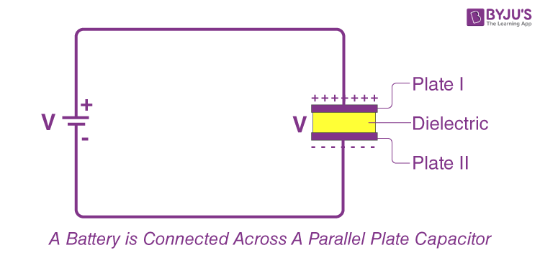**An electric field appears across the capacitor. The positive plate (plate I) accumulates positive charges from the battery, and the negative plate (plate II) accumulates negative charges from the battery.  After a point, the capacitor holds the maximum amount of charge as per its capacitance with respect to this voltage. This time span is called the *charging time of the capacitor*.**

**When the battery is removed from the capacitor, the two plates hold a negative and positive charge for a certain time. Thus, the capacitor acts as a source of electrical energy.**

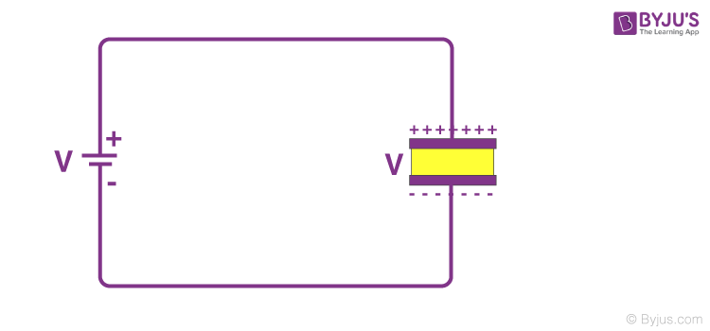**If these plates are connected to a load, the current flows to the load from Plate I to Plate II until all the charges are dissipated from both plates. This time span is known as the *discharging time of the capacitor***

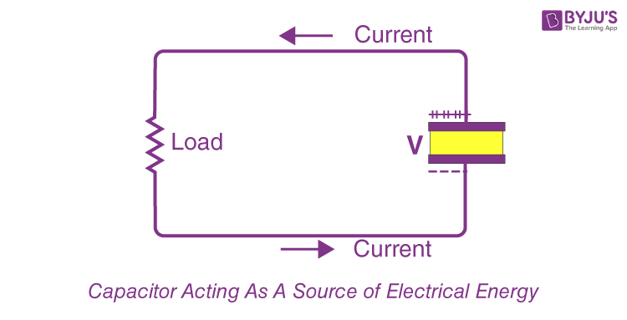

## How Do You Determine the Value of Capacitance?

**The conducting plates have some charges Q1 and Q2 (Usually, if one plate has +q, the other has –q charge). The**[**electric field**](https://byjus.com/physics/electric-field-of-point-charge/)**in the region between the plates depends on the charge given to the conducting plates. We also know that potential difference (V) is directly proportional to the electric field hence we can say,**

$$\begin{aligned}Q∝V\end{aligned}$$

$$\begin{aligned}Q=CV\end{aligned}$$

$$\begin{aligned}C=\frac{Q}{V}\end{aligned}$$

**NOTE: This constant of proportionality is known as the capacitance of the capacitor.**

**Capacitance is the ratio of the change in the electric charge of a system to the corresponding change in its electric potential.**

**The capacitance of any capacitor can be either fixed or variable, depending on its usage. From the equation, it may seem that ‘C’ depends on charge and voltage. Actually, it depends on the shape and size of the capacitor and also on the insulator used between the conducting plates.**